**The Tragedy Of Flight: A Comprehensive Crash Analysis**

1. **INTRODUCTION**
   1. **Overview**

**An airplane crash analysis is a detailed investigation into the causes of an aviation accident.**

* 1. **Purpose**

**The goal of an airplane crash analysis is to identify any factors that contributed to the accident, with the ultimate goal of improving safety and preventing future accidents.**

1. **PROBLEM DEFINITION & DESIGN THINKING**
   1. **Empathy Map**

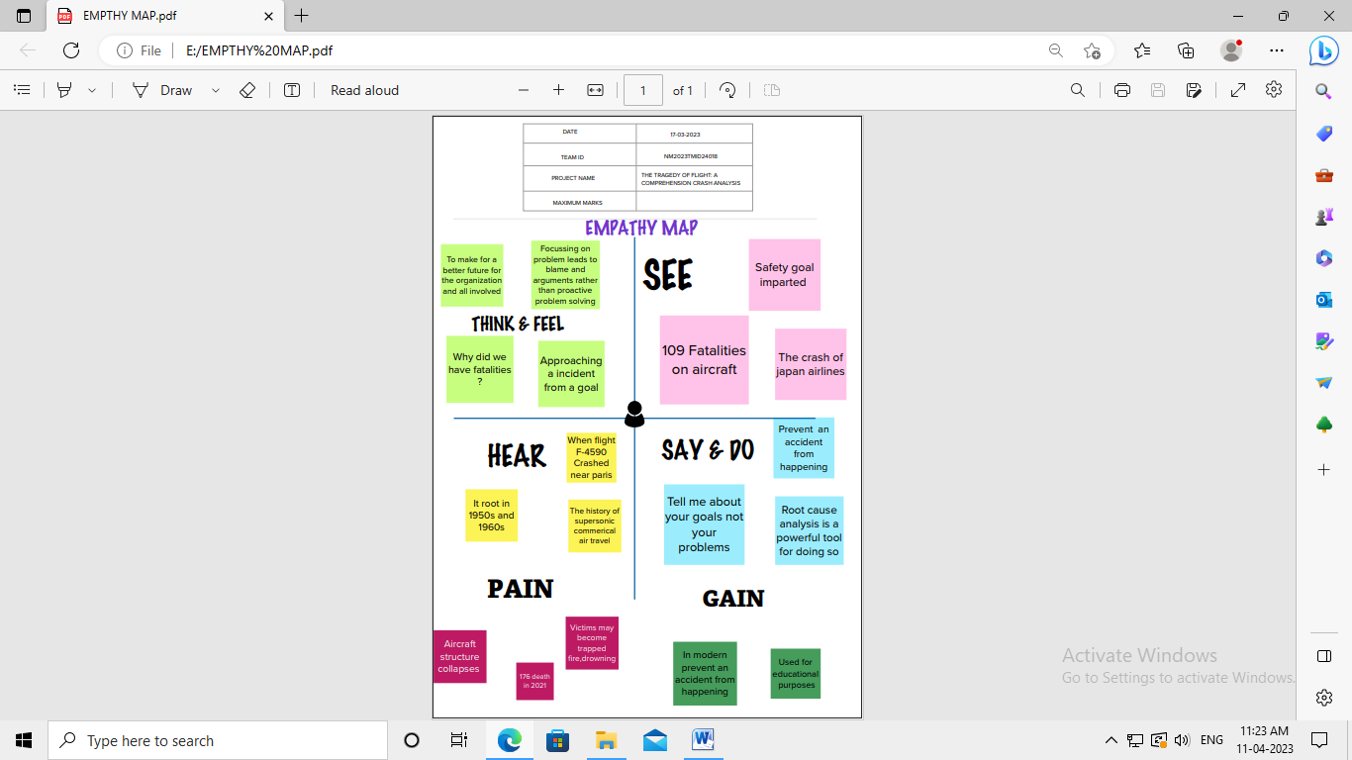

# 2.2 Ideation & Brainstorming Map

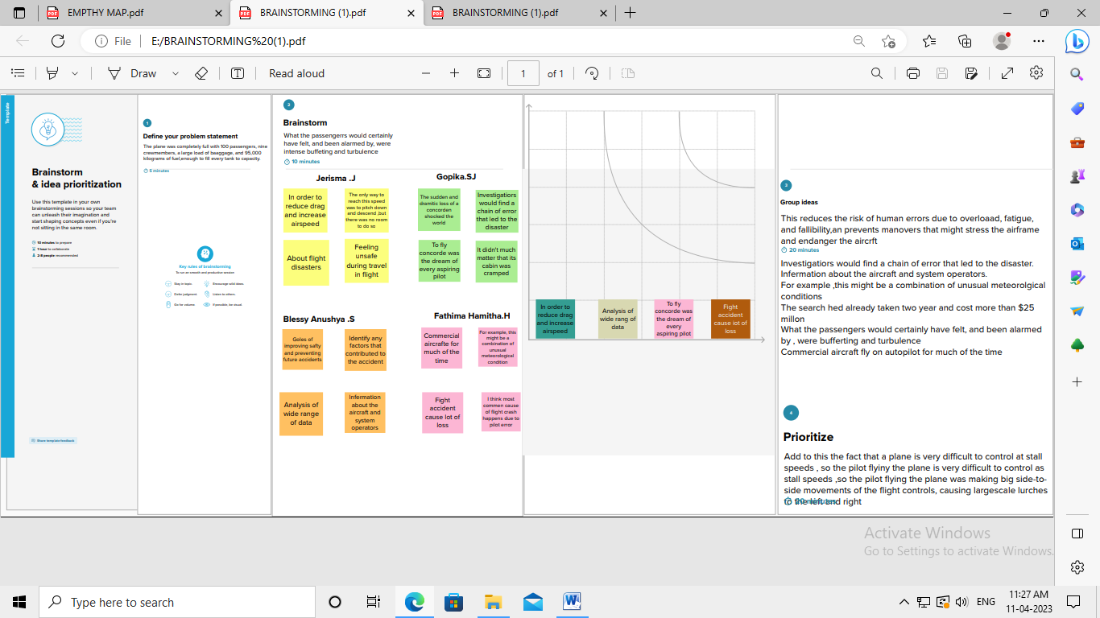

1. **RESULT**

**3.1 Comparing Aboard Vs Fatalities Vs Ground**

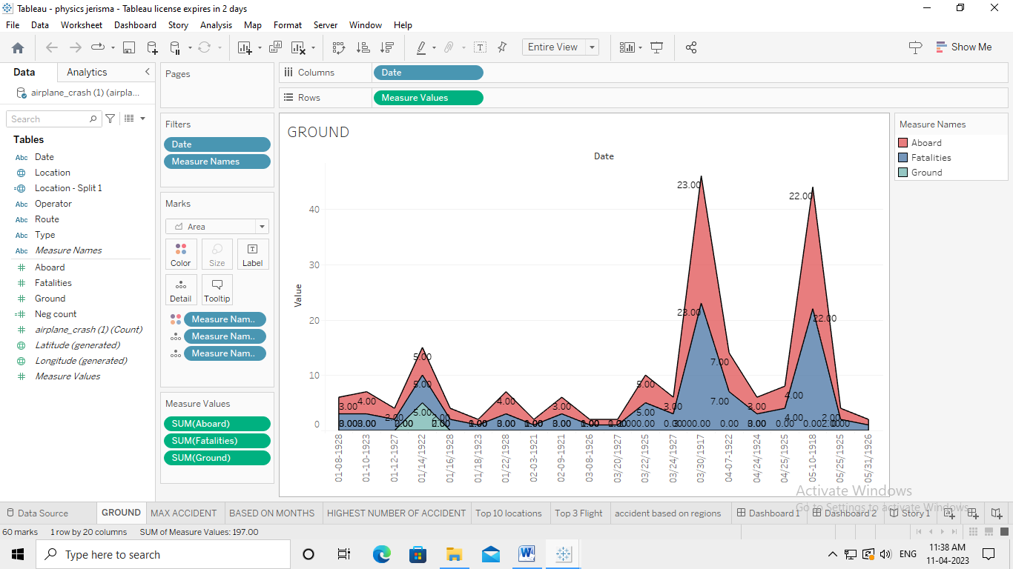

**3.2 Max Accident Based On Years**

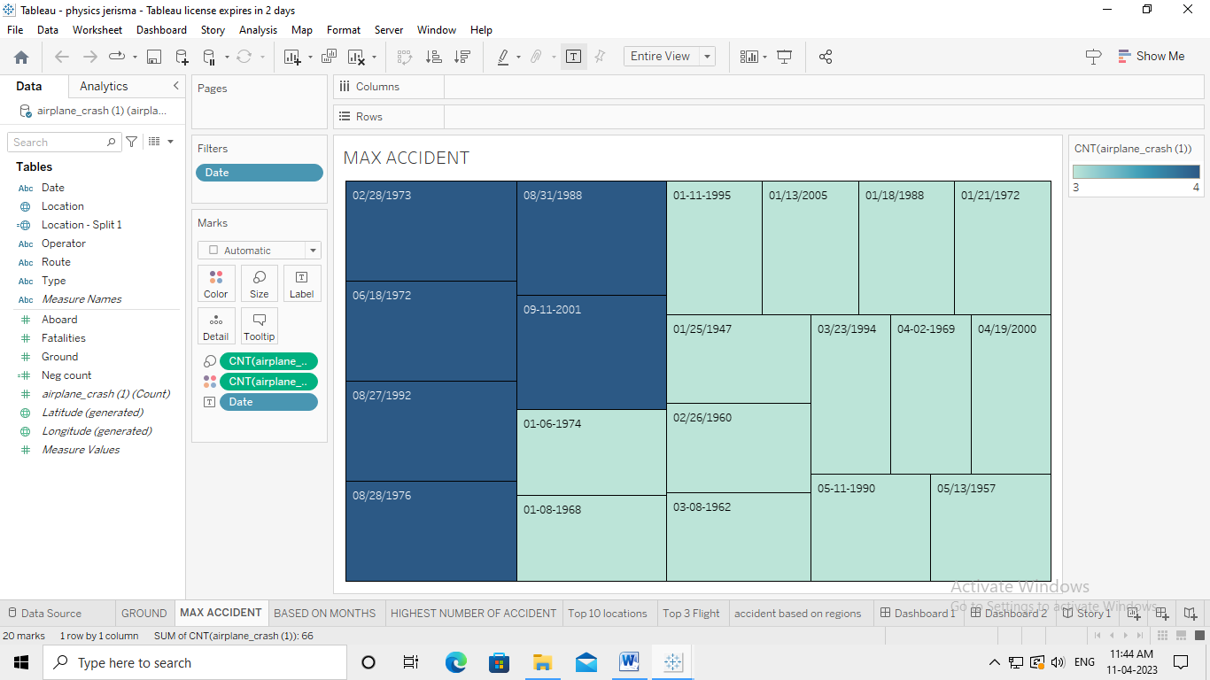

# 3.3 Accidents Happened In 1972 (MAX ACCIDENTS) Based on Months

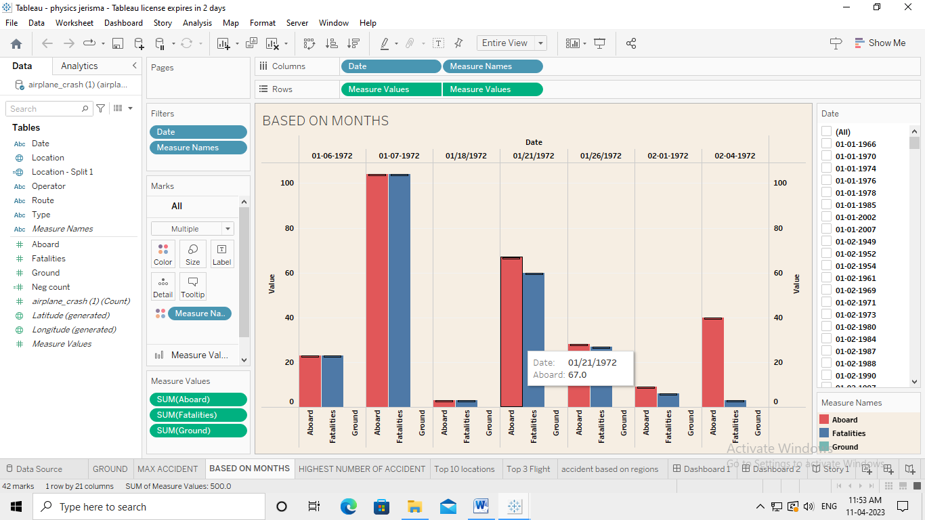

# 3.4 Highest No. Of Accident Happened By Operators

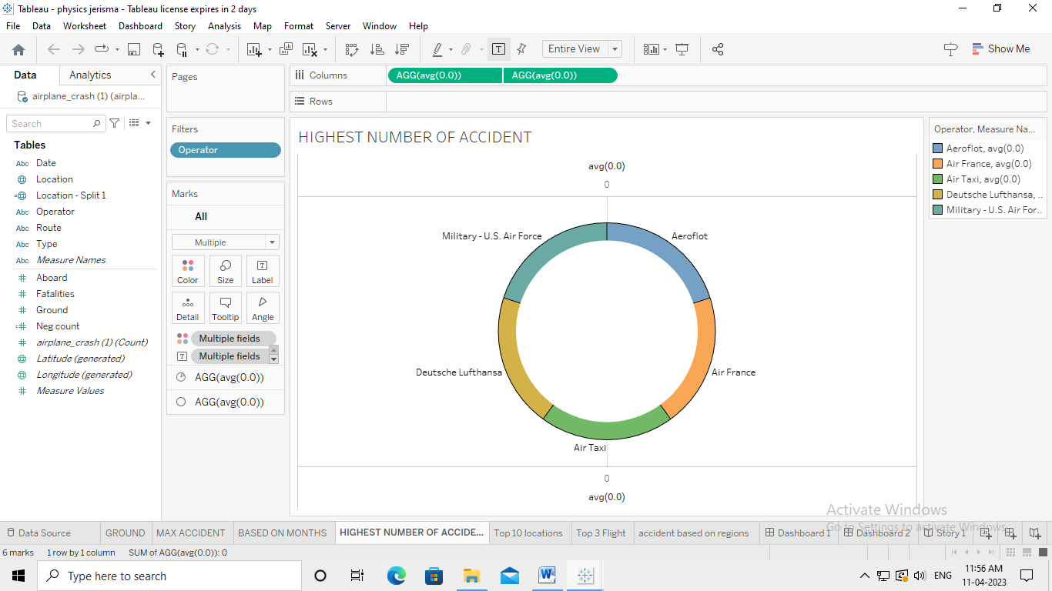

# 3.5 Top 10 Locations Which Had More Accidents

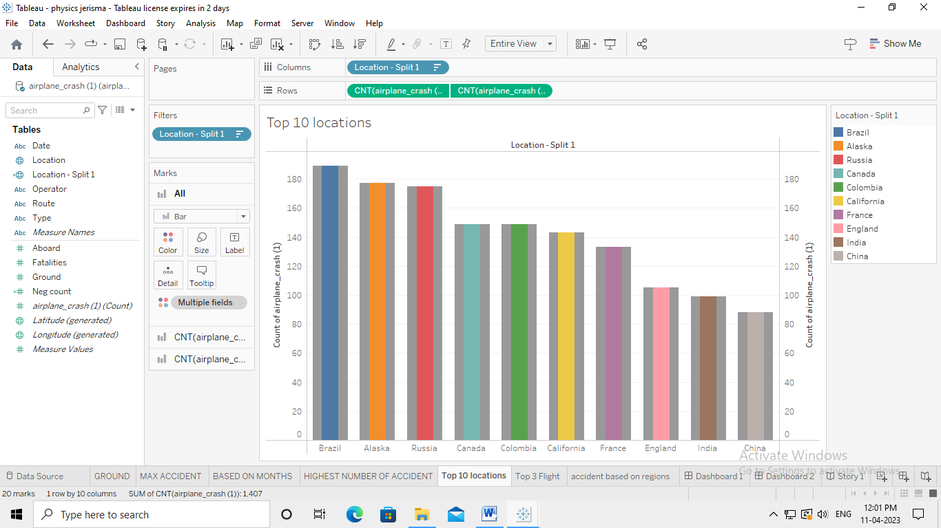

# 3.6 Top 3 Flights Which Have Max Accident History

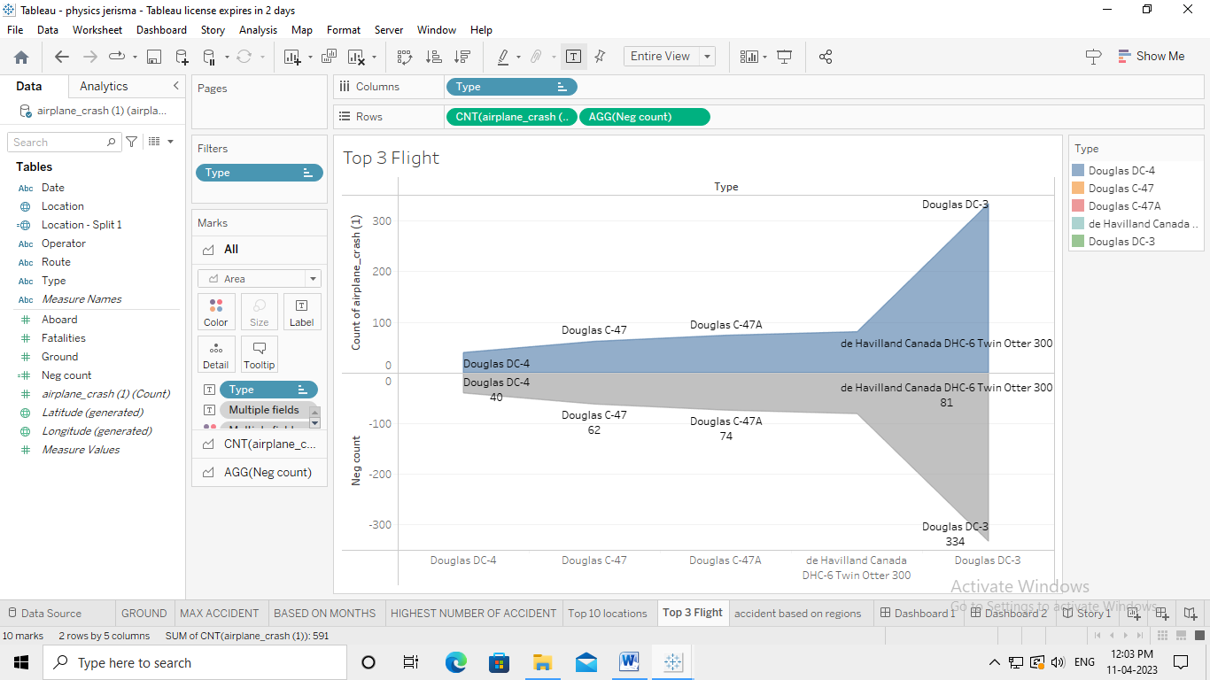

# 3.7 Accident Based On Regions

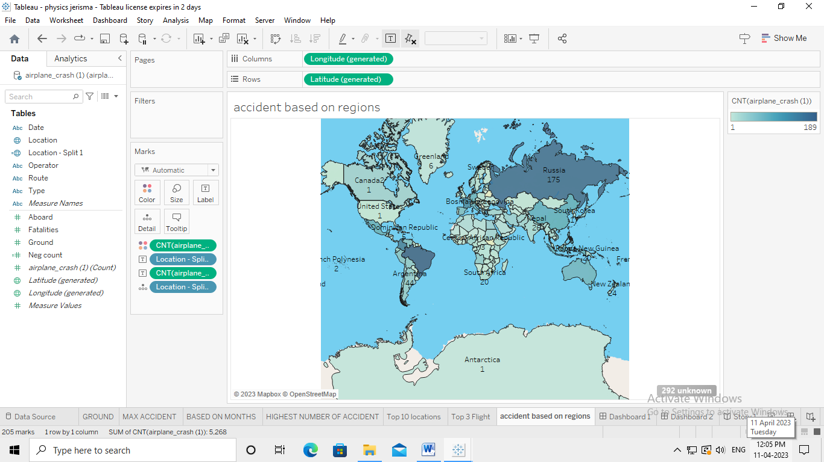

# 3.8 Dashboard 1

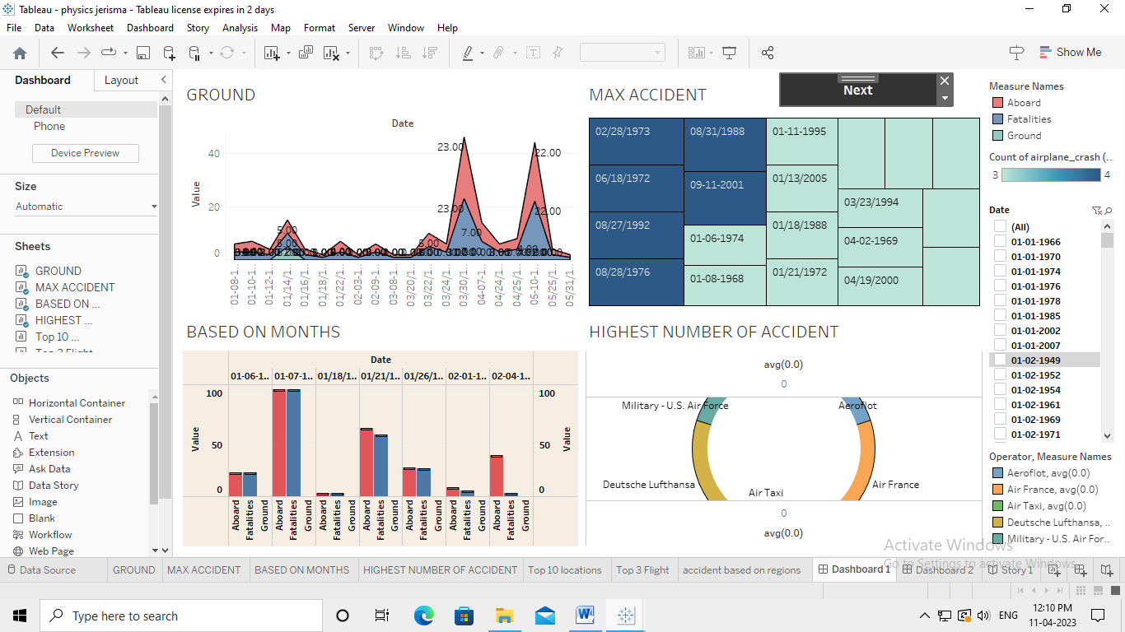

# 3.9 Dashboard 2

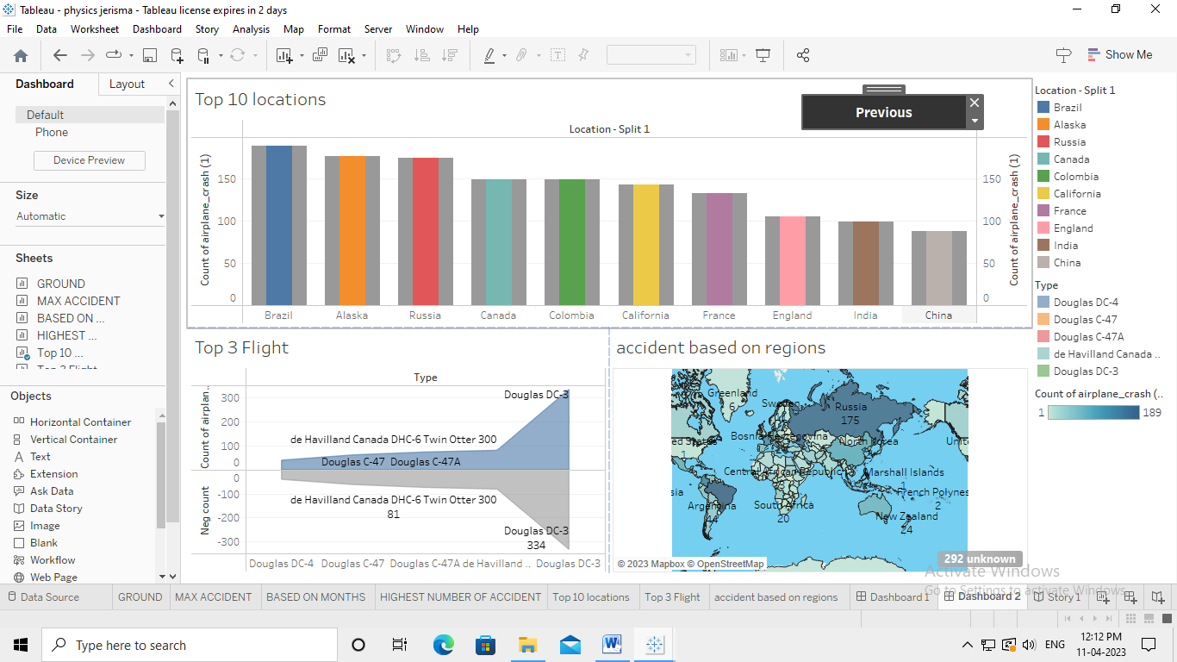

# 3.10 Story

# 

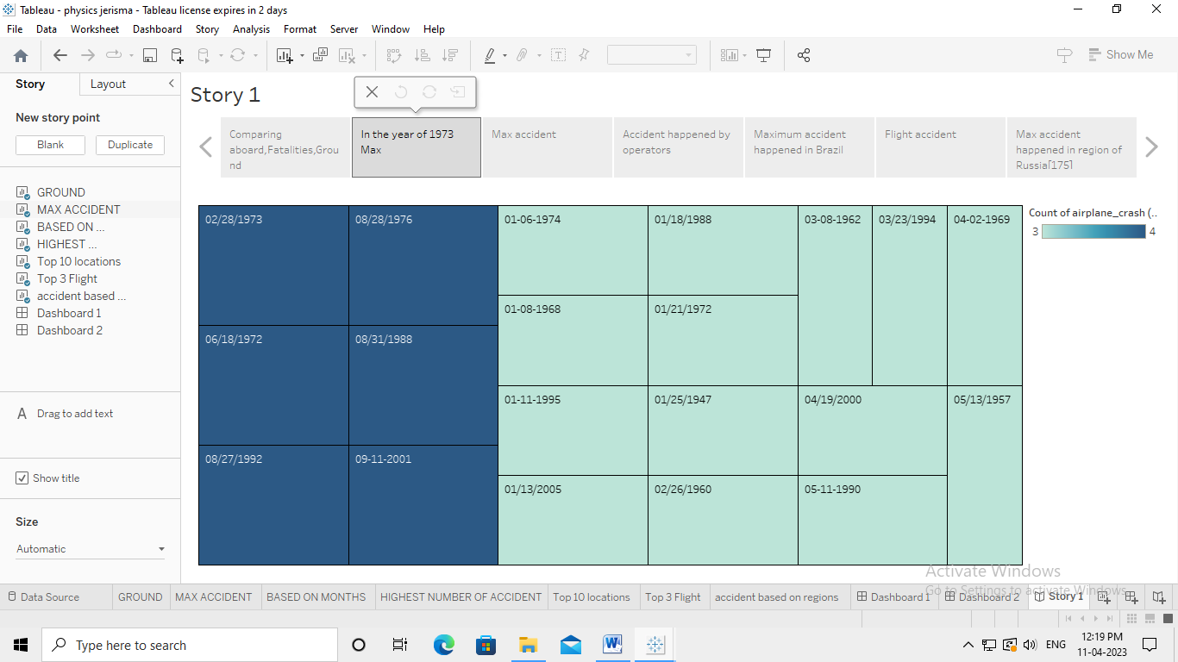

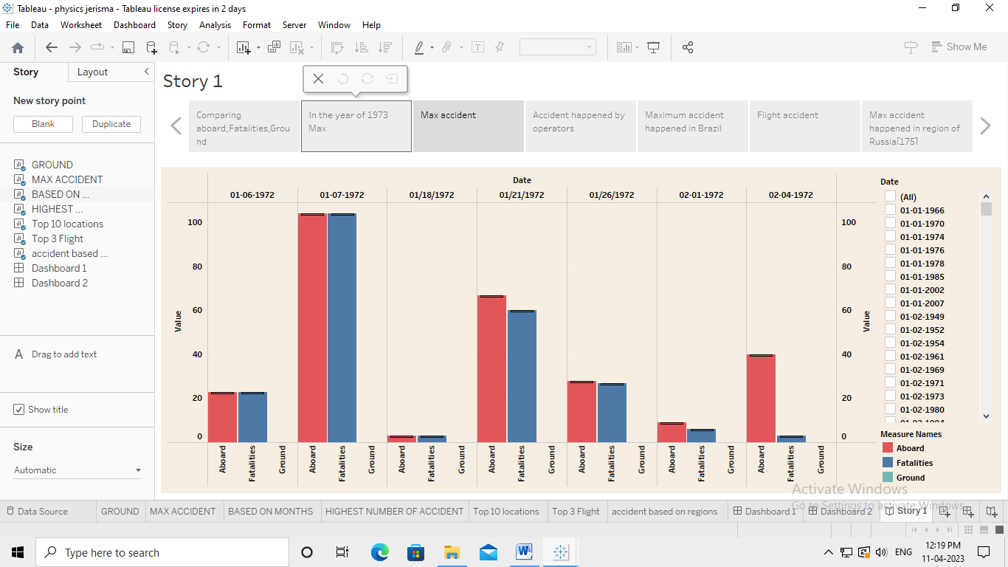

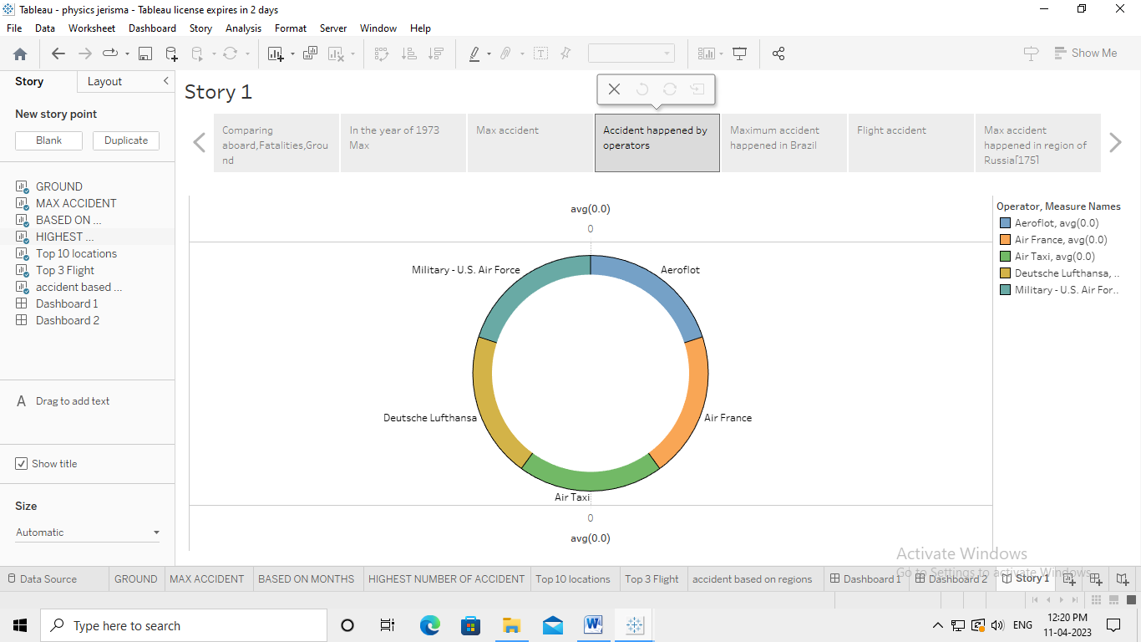

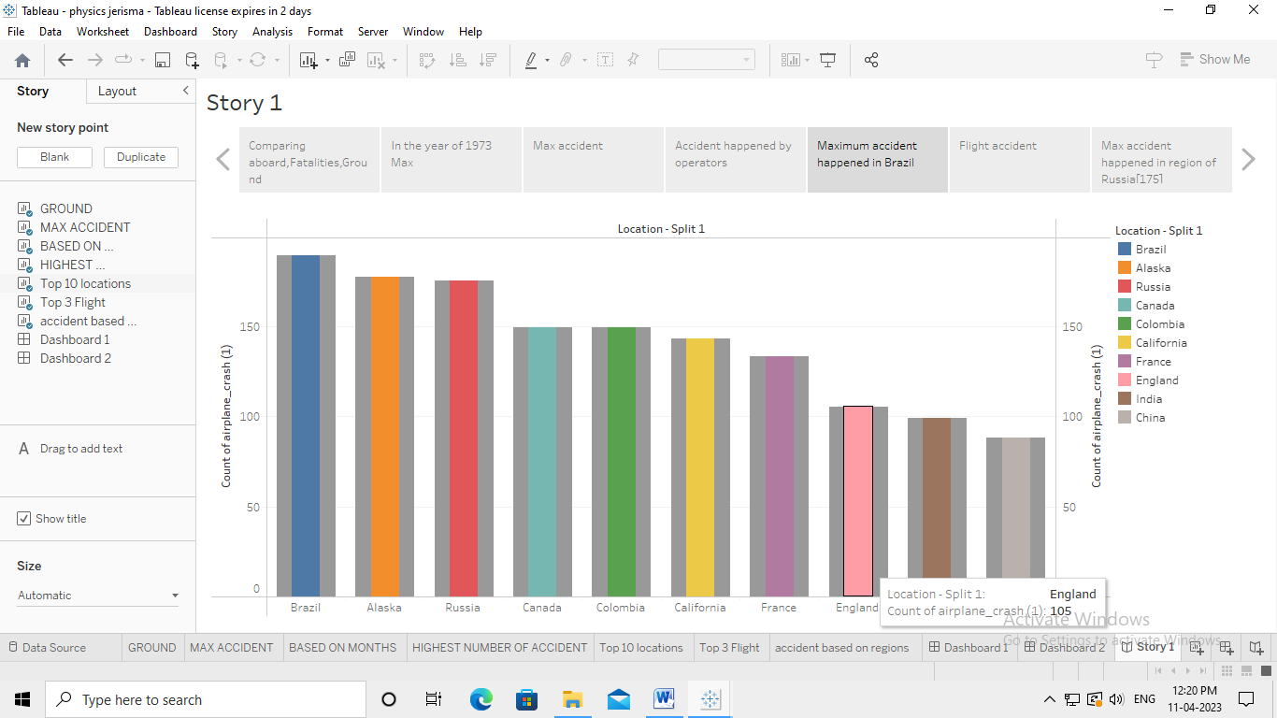

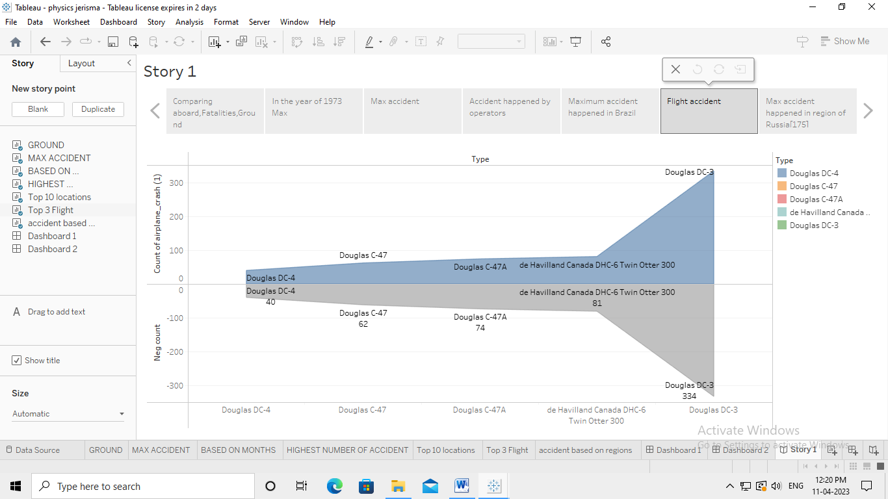

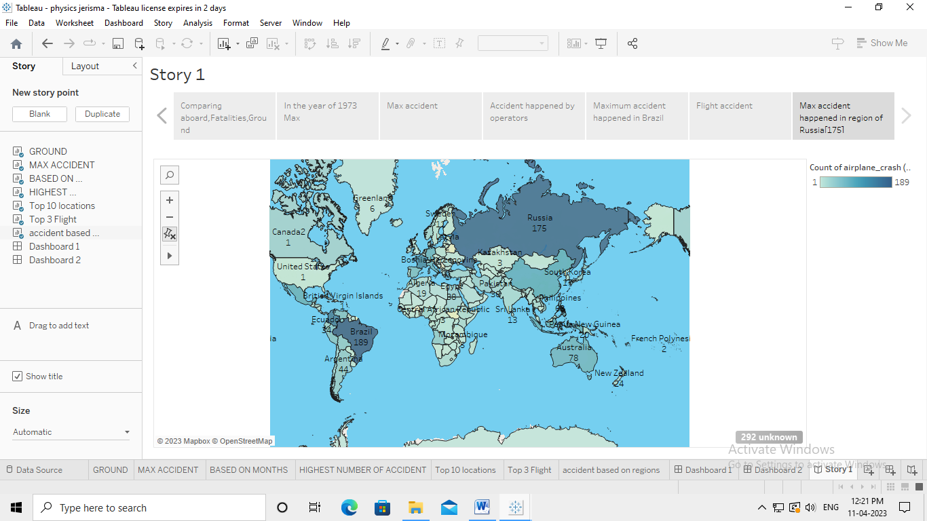

# ADVANTAGES

* Provides Financial Security to your Family and loved ones.
* There no external tests and documents needed over and above the current condition .
* Extensive coverage at much affordable rates.
* Each accident should be treated as a planning opportunity .
* Understanding the events that led up to an accident can help to determine the cause.

# DISADVANTAGES

* Human Errors in Aviation. Pilot error is the number one cause of aviation accidents.
* Mistakes By Crew Members.
* Air Traffic Controller Negligence.
* Weather Conditions.
* Improper Aircraft Maintenance.
* Aircraft Design Defects.
* Glide Slope Indicators.

# 5. APPLICATIONS

**To effectively discover the hazards that led to the accident and to prevent their recurrence in a future accident or incident**. In the course of that investigation, additional hazards which increased damage and injury (inadequate crashworthy systems, system safeguards, rescue team response, etc.)

# 6. CONCLUSION

This analysis revealed that among the pilots that caused the targeted accidents, 22 had flight experience for 301 to 1000 hours and 20 had 1001 or more hours of experience. By age, those in their 50s and 60s combined were 34, accounting for nearly 60% of the total. Pilots with the total flight time of 301 to 1000 hours may have accumulated experience in familiarization flights and recreational flights after obtaining a license and may have become confident in their skills. On the other hand, the analysis of causal factors shows the involvement of human factors, such as wrong assumptions carelessness and negligence, as well as a gap between perceptions and reality concerning skills, in many of the accidents. There was also a case where a pilot's excessive self-confidence triggered the accident. In the interviews some pointed out the importance of cautioning oneself against all dangerous situations instead of taking them lightly. However experienced you may be, you should refrain from dangerous and reckless flights. Be aware that you may do something careless or make errors at any moment, be sure to conduct periodic checks and prior confirmation, and try to take action as soon as possible instead of ignoring any abnormalities or anxiety you may notice during the flight. Such attitude of each pilot will lead to preventing aircraft accidents. Lastly, we extend our appreciation to the people from the Japan Flying

# 7. FUTURE SCOPE

A recent report suggested that **hydrogen-powered planes could enter the market as soon as 2035**, and those planes could carry hundreds more passengers per flight than traditional planes, with a cleaner energy source.

# 8. APPENDIX

# Source Code

# file:///C:/Users/User/Documents/flight.html